

SYSTEM DESIGN DOCUMENT & PROPOSAL
Finder Portal
Project 01: Comprehensive Backend System
Course Code: CSX4110
Team Members:
Thanadon Ruangpakdee 6610308
Kitirat Pisithaporn 6610387
Thanakrit Kodklangdon 6610936
Submission Date: July 22, 2026

1. Project Domain & Overview
On a large university campus, lost property events occur daily. Currently, the university handles lost items in a highly fragmented manner items are handed to scattered security offices, administrative desks, or advertised casually on public social media groups. This lack of centralized record-keeping creates immense friction for students and faculty searching for their belongings.
Finder Portal is a centralized web platform designed to streamline reporting, cataloging, searching, and returning lost and found items. By providing a searchable digital log, automating categorization via artificial intelligence, and establishing secure service-to-service communication with existing campus systems, the portal minimizes processing times and maximizes matching success rates.
2. Core Features
- Report Lost Item: Allow users to submit detail descriptions, approximate locations, dates, and item categories.
- Report Found Item: Allow finders to submit details, upload a photo, specify location, and log items.
- Search & Filter: Users can browse recent listings and search records by keywords, categories, dates, and locations.
- Submit Claim Request: Allows students/faculty to request item retrieval by submitting detailed claims (describing identifying features not visible in public listing photo). Staff will verify proof and confirm returns.
- AI-assisted Matching & Categorization: The system uses Gemini/OpenAI API to automatically analyze images or textual descriptions to assign appropriate categories and flag potential matching pairs.
- Admin/Staff Dashboard: Provides security/reception office staff with metrics on resolved/unresolved cases, claim trends, and pending claims.
3. User Roles & Role-Based Access Control (RBAC)
Users will authenticate via OIDC using the University's Microsoft Active Directory (AD). Based on OIDC claims, users are mapped to the following RBAC roles:
Role | Authorized Permissions
Student / Faculty | - Report lost and found items.  - View personal reporting history.  - Submit claims on found items.
Staff (Security / Desk) | - View all records.  - Verify claims and approve/reject them.  - Update item statuses (e.g., mark as claimed).
Admin (IT / Management) | - Manage user configurations.  - View dashboard analytics & statistics.  - Delete inappropriate or spam listings.

4. Database Schema (ERD)
The database represents a normalized relational schema for the Finder Portal:
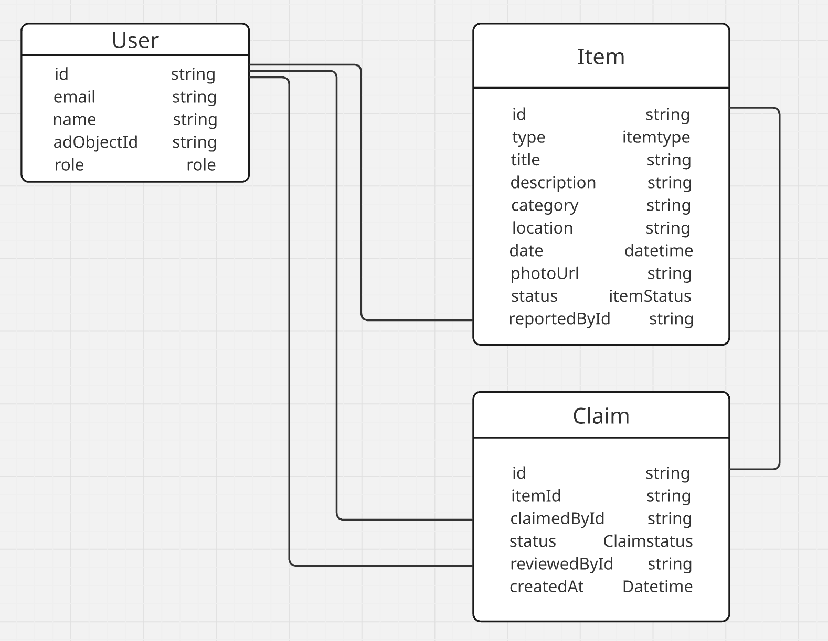
5. External & AI Integration
1. Google Gemini AI API (Multimodal):
- Category Tagging: Analyzes images of uploaded found items or textual descriptions to automatically classify items under appropriate categories, reducing human categorization error.
- Match Recommendation: Compares records between the LOST and FOUND domains using text embeddings and image similarities, flagging matching probabilities for admin review.
2. SendGrid Email API / Line Notify:
- Sends automatic transactional notifications to the owner's university email when their claim status shifts from PENDING to APPROVED or REJECTED.
6. Peer API Integration (Service-to-Service)
Our application will integrate with SpaceReserve (peer project) to exchange operational data:
Exposed Endpoint (Service Provided to Peer)
- Endpoint: GET /api/v1/items/by-location
- Authentication: Expecting header x-api-key: <static_api_key_we_issue_to_spacereserve>
- Function: Allows SpaceReserve to fetch all found items logged in a specific room (via ?location=RoomName) so they can alert students checking in if any lost items were recently found there.
Consumed Endpoint (Service Pulled from Peer)
- Endpoint: GET /api/v1/external/bookings/active-at
- Authentication: Authorization: Bearer <api_key_issued_by_spacereserve> in headers
- Function: When an item is found, we query SpaceReserve's API to fetch the booking details of who occupied that room at that time (via ?location=Library Room 4B&time=2026-07-20T14:00:00), enabling us to notify the likely owner directly.

